Model / Domain Resource

📝Definition
# Source: AI Source: Provided by: [Data Path: Persons Table -> ID Column: 1, Name_En Column: Motasem Essam] -> From: [ChatGPT] on [1/23/2026]
A Model / Domain Resource represents the core business entities and rules of your application. It defines what your system is about (Users, Orders, Products) and contains the business logic related to those entities.
👉 Think of it as the heart of your application — it represents real-world concepts and enforces business rules.

🔑 Key Points
# Source: AI Source: Provided by: [Data Path: Persons Table -> ID Column: 1, Name_En Column: Motasem Essam] -> From: [ChatGPT] on [1/23/2026]
- Represents business entities (User, Order, Product, etc.)
- Contains business rules and logic, not UI or infrastructure
- Often maps to database resources, but not always
- Used by Services, Controllers, and Repositories

🧱 Examples

1️⃣ Simple Domain Model (Java)
# Source: AI Source: Provided by: [Data Path: Persons Table -> ID Column: 1, Name_En Column: Motasem Essam] -> From: [ChatGPT] on [1/23/2026]
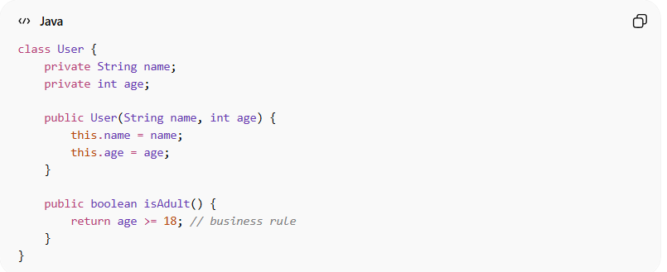
class User {
private String name;
private int age;

public User(String name, int age) {
this.name = name;
this.age = age;
}

public boolean isAdult() {
return age >= 18; // business rule
}
}
👉 Here:
- User is a domain resource
- Contains business logic (isAdult)

2️⃣ Laravel Example (Eloquent Model)
# Source: AI Source: Provided by: [Data Path: Persons Table -> ID Column: 1, Name_En Column: Motasem Essam] -> From: [ChatGPT] on [1/23/2026]
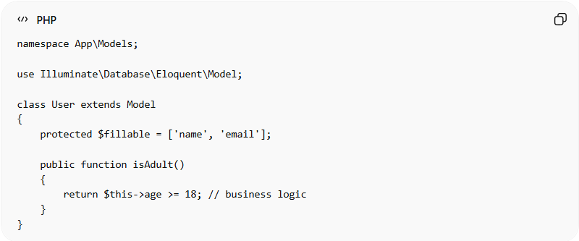
namespace App\Models;

use Illuminate\Database\Eloquent\Model;

class User extends Model
{
protected $fillable = ['name', 'email'];

public function isAdult()
{
return $this->age >= 18; // business logic
}
}
👉 Here:
- User represents the domain entity
- Maps to the database resource (users table)
- Can include business rules

❌ Bad Example
# Source: AI Source: Provided by: [Data Path: Persons Table -> ID Column: 1, Name_En Column: Motasem Essam] -> From: [ChatGPT] on [1/23/2026]
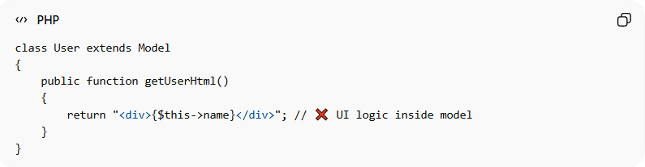
class User extends Model
{
public function getUserHtml()
{
return "<div>{$this->name}</div>"; // ❌ UI logic inside model
}
}
Problems:
- Mixes UI logic with business logic
- Violates separation of concerns
- Makes the model harder to maintain

✅ Good Example
# Source: AI Source: Provided by: [Data Path: Persons Table -> ID Column: 1, Name_En Column: Motasem Essam] -> From: [ChatGPT] on [1/23/2026]
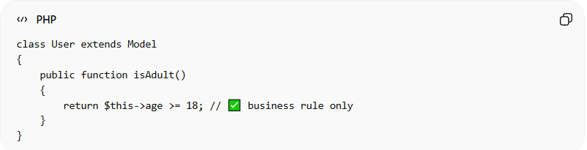
class User extends Model
{
public function isAdult()
{
return $this->age >= 18; // ✅ business rule only
}
}
- Keeps domain logic clean and focused
- UI handled elsewhere (View/Template)

🔄 Relation to Other Resources
# Source: AI Source: Provided by: [Data Path: Persons Table -> ID Column: 1, Name_En Column: Motasem Essam] -> From: [ChatGPT] on [1/23/2026]
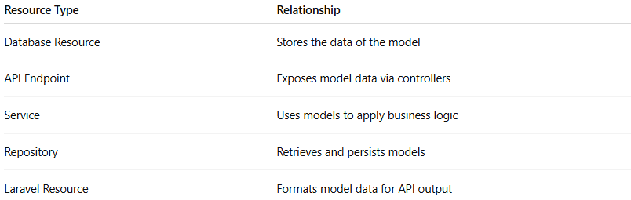
Resource Type | Relationship
Database Resource | Stores the data of the model
API Endpoint | Exposes model data via controllers
Service | Uses models to apply business logic
Repository | Retrieves and persists models
Laravel Resource | Formats model data for API output

⚠️ Common Mistakes
# Source: AI Source: Provided by: [Data Path: Persons Table -> ID Column: 1, Name_En Column: Motasem Essam] -> From: [ChatGPT] on [1/23/2026]
- Putting UI logic in models ❌
- Putting database queries everywhere instead of using models ❌
- Making models too large with unrelated responsibilities ❌

💡 Key Idea
# Source: AI Source: Provided by: [Data Path: Persons Table -> ID Column: 1, Name_En Column: Motasem Essam] -> From: [ChatGPT] on [1/23/2026]
A Model / Domain Resource represents business entities and rules, forming the core logic layer of the application.

🧾 Summary
# Source: AI Source: Provided by: [Data Path: Persons Table -> ID Column: 1, Name_En Column: Motasem Essam] -> From: [ChatGPT] on [1/23/2026]
- Represents business data and rules
- Independent from UI and infrastructure
- Often maps to database tables
- Used across services, controllers, and repositories

